**Lesson 9 Demo 1**

**How to Install Nagios Monitoring Tool**



Steps to be followed:

1. Updating the packages
2. Installing the latest version of Nagios XI

|  |
| --- |
| **Note:** You need a blank ubuntu lab before you proceed with installations. Any pre-installed tool/package might interfere with the installation process giving errors. So kindly, **terminate** the lab access and launch a fresh lab instance before you proceed with this demo. |

**Step 1: Updating the packages**

1. Update the packages using the following command:

***sudo apt update***

**Step 2: Installing the latest version of Nagios Xi**

1. Login as the root user using the command given below

***sudo -i***

1. Execute the below command to install Nagios XI

***curl https://assets.nagios.com/downloads/nagiosxi/install.sh | sh***

|  |
| --- |
| **Note:** The installation takes around 20 mins. Please wait patiently till you get the ***Installation Complete*** message as shown below |

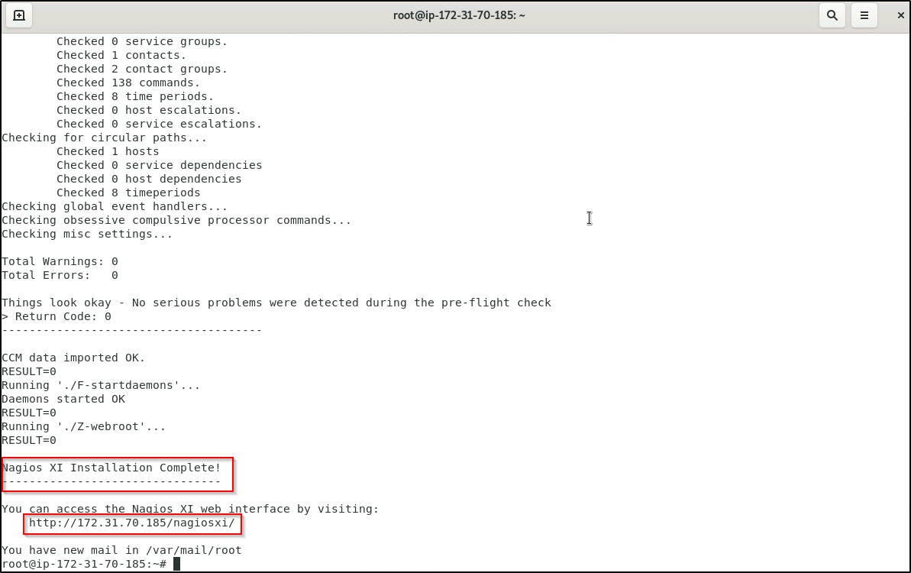

1. Navigate to the user interface by using the URL provided in your terminal session. You can refer to the screenshot given above.
2. You will be presented with the Nagios XI Installation screen as shown below

### 

1. You will be first prompted to define the General System Settings
2. Once you've made your desired selections choose your License Settings. Here for demonstration purposes we have chosen a trial version.
3. You will have to enter a key for the trial version. To get the key, click on the **click to get a trial key** link. You will be asked to enter details like the first name, last name and email id. Once you enter all those you will get the key mailed to the email-id you just mentioned. Enter the key as shown below

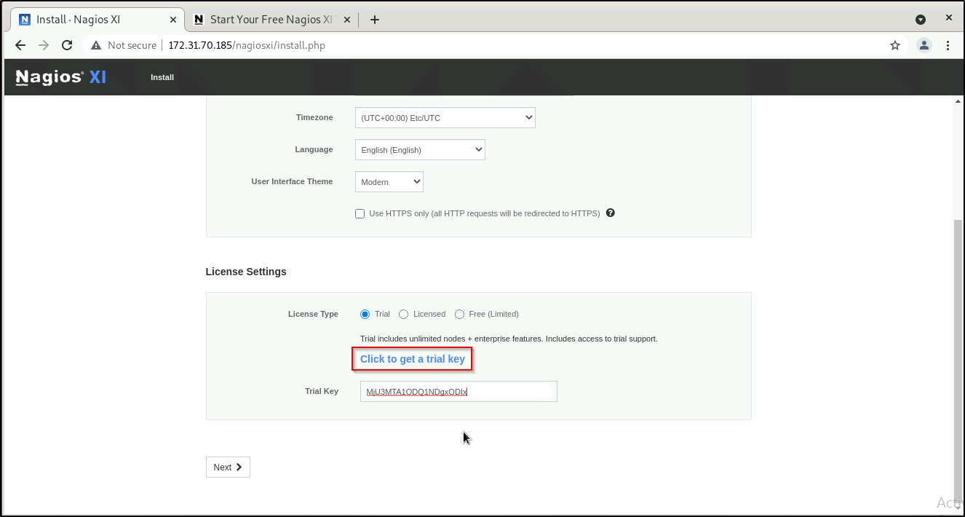

1. Click **Next** to proceed.
2. The next page provides you with options for the Admin Account. You can use the default password or change it if you want. After this click on ***Finish Install***

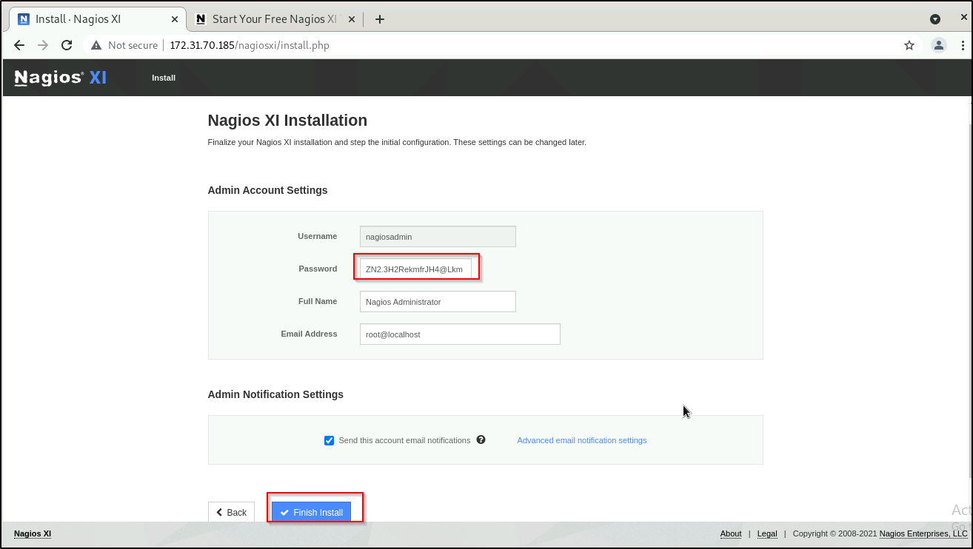

1. The page will display a spinning logo while it applies your settings to Nagios XI.
2. The Installation Complete screen will be shown with the username and password required to login to Nagios XI.
3. Click the Login to Nagios XI button to begin.

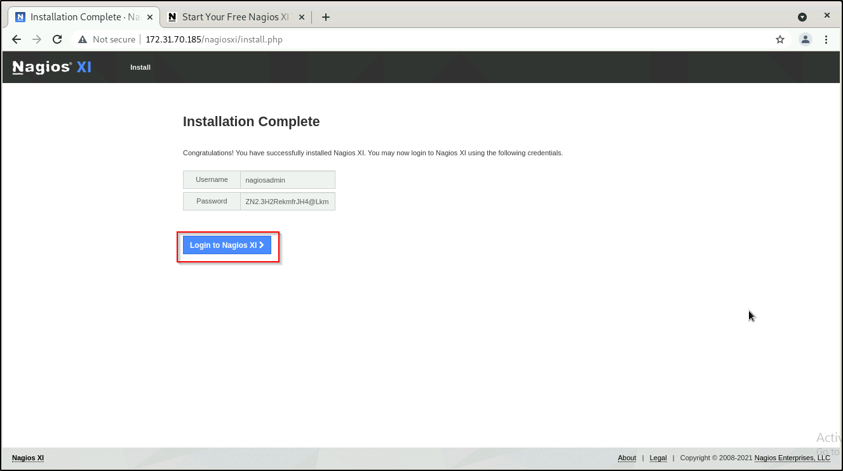

1. The Login Screen will appear, provide your credentials and then click the Login button.

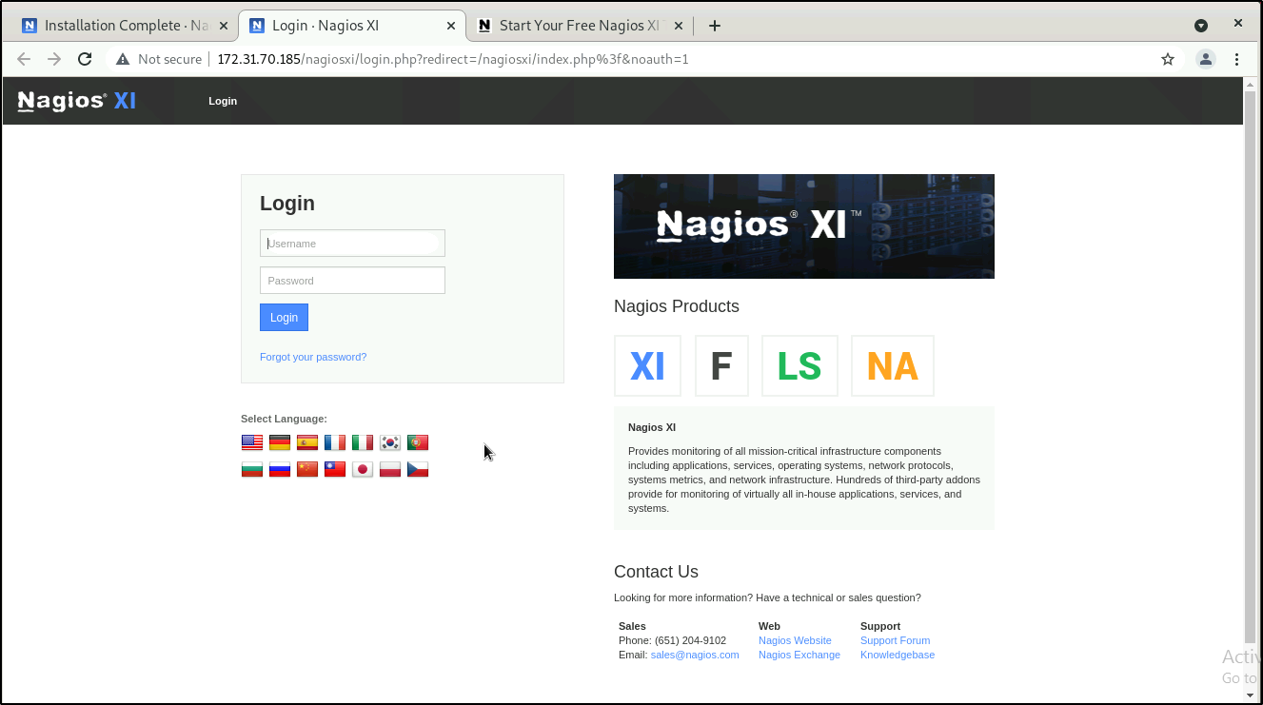

1. You will need to accept the License Agreement to proceed.

### 

1. You will be logged into Nagios XI and be placed at the home screen.

